

**HOW TO USE:**

**Google Meet**

**Google Meet can improve the efficiency and delivery of online classroom learning. Users can use Google Meet tools and features for digitally mediated collaboration and communication. This platform enhances and supports student learning by encouraging participation. Users can learn and practice netiquette, which is the set of professional and social etiquettes that are implemented and advocated in electronic communication.**

How toCreate A Google Account

Step1:

In order to use the Google Meet platform, you must have a 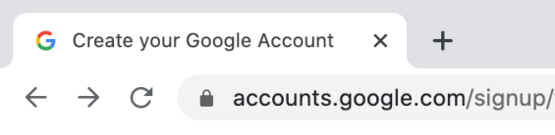

Google account. To create a Google account,

enter **https://accounts.google.com/signup** into your web

browser and it will direct you to the form.

Step2: 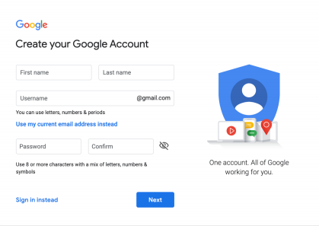

Complete the sign up form with your personal

information and create a username and password

for your account. Click **Next** to finish making your

account.

Step3: 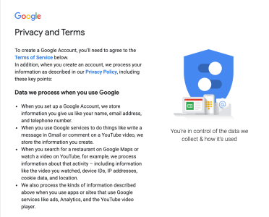

Click **I Agree** to Google's Privacy and

Terms.

You now have a google accounT

Accessible applications with a Google Account

Gmail

Gmail is a free email service provided by Google. It is accessible on the web through any web search engine.

Once you have created a Google Account, you are given a Google email account with your chosen username. You can access your Gmail account by going to the Google Apps Menu icon at the top, right hand corner of your web browser.

Googlecalendar

Google Calendar is a free scheduling and time management service provided by Google. It is accessible on the web through any web search engine.

Once you have created a Google Account, you can access Google Calendar by going to the Google Apps Menu icon at the top, right hand corner of your web browser.

Tip: schedule video meetings through googlecalendar for direct accessto Meet

How tostart a video meetingor videolesson from meet 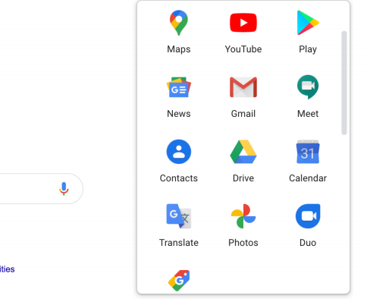

Step1:

Once you have created a Google account or logged in to an

existing account, go to the Google homepage and click the

**Google Apps Menu icon** (3 dots) at the top, right hand corner

of your web browser. You will see the Google Meet icon.

Step2: 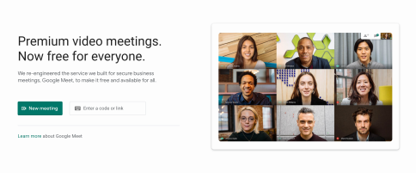

Click the **Google Meet Icon** and it will direct you to

the application’s main website. Click **New Meeting**

to start a new meeting or create a new meeting.

Step3: 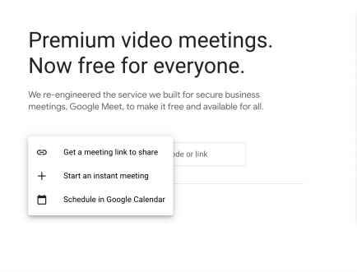

Select an option from the drop menu based on your needs:

Meeting Link to Share: generate link to share now or later

Start an Instant Meeting: invite others right away

Schedule in Google Calendar: schedule the meeting for a

specific date and invite students or colleagues later

3 ways tojoin a video meeting

by meetingcodeor link:

1.

Enter **https://meet.google.com/** in your web browser 2.

Enter the meeting **code** (letters at the end of meeting link) or copy and paste the **link** of the meeting in the space provided Note: if using code, omit hyphens (ex: dvkbwxykts) 3.

Click **Continue**, then **Join Now**

FROM Gmail:

1.

Open **Gmail** from the Google Apps Menu in the top right corner of the Google home browser

2.

Open your Google Meet email invitation

3.

Click the **joining link** under "Joining Info" in your email 4.

Click **Join Now**

from a scheduled googlecalendar event:

1. 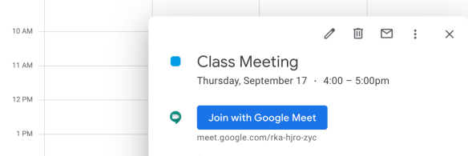

Open **Google Calendar** from the Google Apps Menu in the top right corner of the Google home browser 2.

Select the Google Meet meeting from your list of scheduled events

3.

Click **Join with Google Meet,** then **Join Now**

**HOW TO USE:**

**Google Meet Features**

Screen Features

SHareyour screen:

1.

In Google Meet, click **Present Now** to open the menu at the bottom right corner of your screen

2.

You will see a drop menu. You can share:

a. b. c.

your entire screen a single window a chrome tab 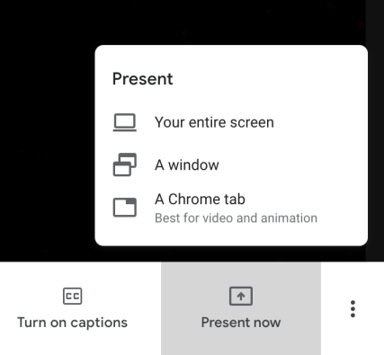

3.

To end screen sharing, click **Stop Sharing** to return to the call.

*Note: Great for sharing presentations and projects Changescreen layout:

1.

In Google Meet, click the **Three Dots Icon** to open the menu at the bottom right corner of the screen 2.

Click **Change Layout** to open the drop menu. 3.

Select an option based on your preferences:

a. 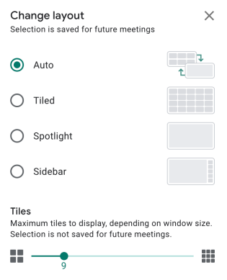

Auto: choses optimal option for your meeting b.

Tiled: shows members in tile format

c.

Spotlight: active speaker will always fill window d.

Sidebar: see image of active speaker and thumbnails of other participants

blur background:

1. 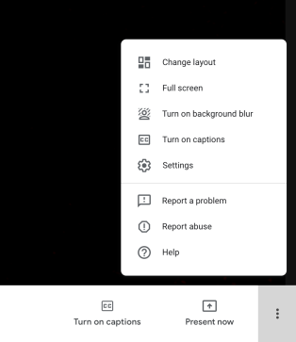

In Google Meet, click the **Three Dots Icon** to open

the menu at the bottom right corner of the screen

2.

Click **Turn on Background Blur** to activate the

function on your screen. The image of your face

will still be seen but your background will be

blurry.

upto100participantsper meetingfor upto60 miniutes

SocialengagementFeatures

Turn Camera on/off:

1. 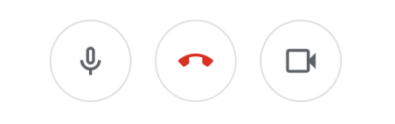

In Google Meet, look for three icons at the bottom center of your screen

2. 

The camera icon is the last button on the right. Click the **Camera Icon** in order to turn your camera on and off:

If the icon is WHITE, your camera is ON.

If the icon is RED, your camera is OFF.

*Note: Great for timid students as well as file and link sharing Turn microphoneON/OFF:

1. 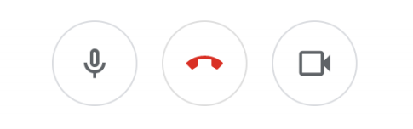

In Google Meet, look for three icons at the bottom center of the screen

2. 

The microphone icon is the first button on the left. Click the **Microphone Icon** in order to turn your microphone on and off:

If the icon is WHITE, your microphone is ON. If the icon is RED, your microphone is OFF.

Usethechatfunction:

1. 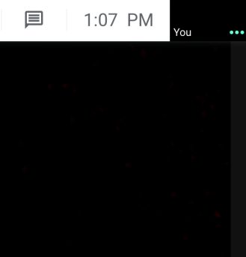

In Google Meet, click the **Chat Icon** in the top right

corner of the window

2.

Enter the message you wish to send to other

participants in the entry box

3.

Click the **Send Icon** shaped as an airplane.

TIP: installgoogle nod reactionsfor A hand raisingfeature

1.

Enter **chrome.google.com/webstore** into your web browser to visit the Google Chrome Web Store 2.

Type **Nod Reactions** into the search bar at the top, left corner. Press **Enter** on your keyboard. The extension will be listed first in your search results. Click on **Nod - Reactions for Google Meet**. 3.

Click **Add to Chrome** to install the free feature, and click **Add Extension**. Once the application has finished downloading, a thumb's up icon will appear at the top right of your window. 4.

When you open Google Meet and join a meeting, you will see different icons students can use at the top left of your screen such as hand raising, thumb's up, and a clapping icons!